Security Information and Event Management (SIEM)
Log Monitoring Project
Project Documentation
Deliverable: Week 1 – SIEM Architecture & Log Onboarding
Date: 3 November 2026
Team: SOC Team
Team Leader: Kareem Yahia Mohammed Elfrony
Team Members:
Sherif Ayman Ahmed
Abdelrhman Ali Ghonemy Ayad
Ahmed Rafiq Ahmed Ashour
Razan Mahmoud Hagagg

1. Project Overview
This project demonstrates the setup and use of Splunk Enterprise on an Ubuntu virtual machine to collect, index, and search security-related log data. The environment uses a combination of simulated attack logs, web access logs, a custom SIEM detection dataset, and the Linux authentication log.

2. Environment and Host Information
- Platform: Ubuntu virtual machine running in VMware.
- Host name shown in the Splunk events: kareem-VMware-Virtual-Platform.
- SIEM platform: Splunk Enterprise 10.0.5.
- Primary index: main (all monitored sources are indexed here).
Figure 1 summarizes the architecture of the current lab: the log files are read by Splunk file-monitoring inputs, parsed and indexed in the main index, and then searched and analysed with SPL queries, detection rules and alerts to support SOC-style monitoring. A proposed architecture for a medium-sized organization is given in Figure 8 (Section 9).
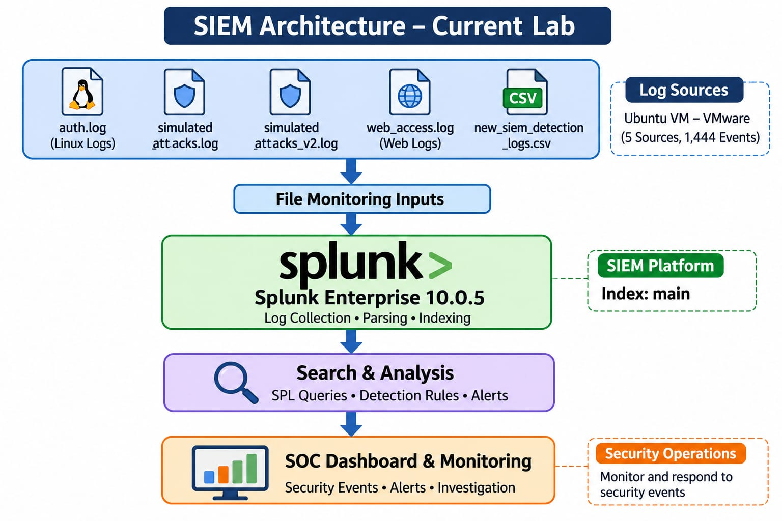
Figure 1 – SIEM architecture of the current lab

3. Log Sources and Data Ingestion
The monitored-file listing confirms that Splunk is configured to monitor the following project log sources, all indexed into main:
Log source | Monitored path | Source type
simulated_attacks.log | /home/kareem/soc-lab/simulated_attacks.log | simulated_attacks
simulated_attacks_v2.log | /home/kareem/soc-lab/simulated_attacks_v2.log | simulated_attacks
web_access.log | /home/kareem/soc-lab/web_access.log | access_combined
new_siem_detection_logs.csv | /mnt/hgfs/LogsShare/new_siem_detection_logs.csv | csv
auth.log | /var/log/auth.log | linux_secure
The terminal output (Figures 2 and 3) was captured using the Splunk CLI command sudo /opt/splunk/bin/splunk list monitor. Its “Monitored Files” section lists the five sources above, plus $SPLUNK_HOME/etc/splunk.version and a second copy of the simulated-attacks log at /opt/splunk/var/log/soc-lab/simulated_attacks_v2.log. The listing also shows the Splunk internal monitored logs and directories.
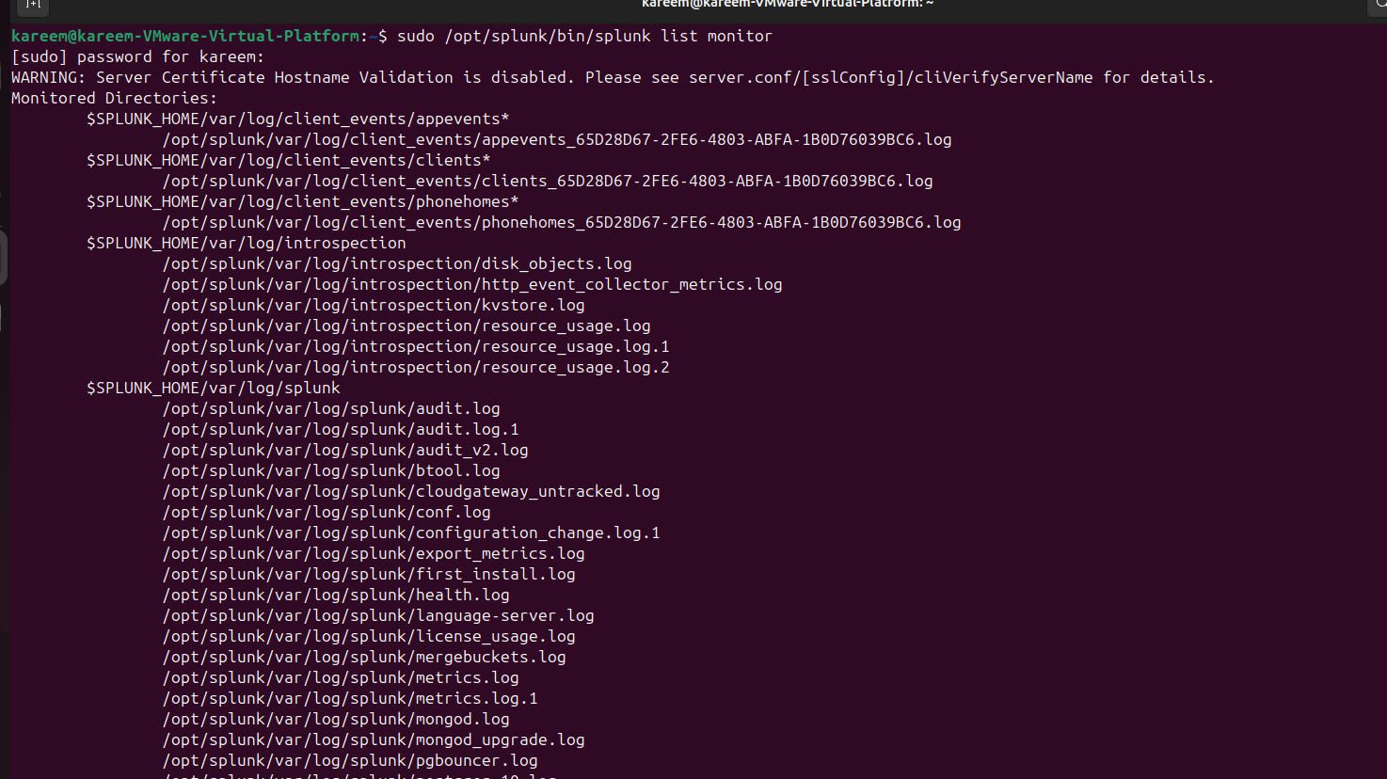
Figure 2 – Output of splunk list monitor (monitored directories)
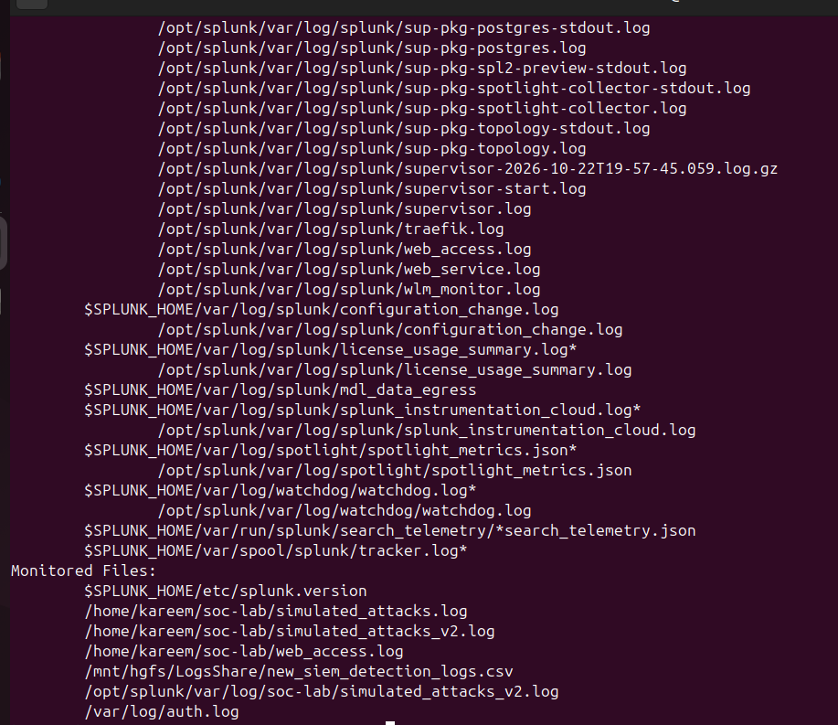
Figure 3 – Output of splunk list monitor (monitored files)

4. Index Configuration
The configuration of the main index was reviewed in Splunk (Settings > Indexes). The index is listed as Active, of type Events, owned by the system app, with the default home path $SPLUNK_DB/defaultdb/db. The Edit Index dialog (Figures 4 and 5) shows the following settings:
- Index data type: Events.
- Home path: default ($SPLUNK_DB/defaultdb/db), field left blank.
- Cold path: default ($SPLUNK_DB/defaultdb/colddb), field left blank.
- Thawed path: default ($SPLUNK_DB/defaultdb/thaweddb), field left blank.
- Data integrity check: Disabled.
- Max size of entire index: 500000 MB.
- Max size of hot/warm/cold bucket: auto_high_volume (GB).
- Frozen path: not set.
- Tsidx retention policy: Disable reduction.
Because no frozen path is configured, data that reaches the end of its retention period is deleted rather than archived.
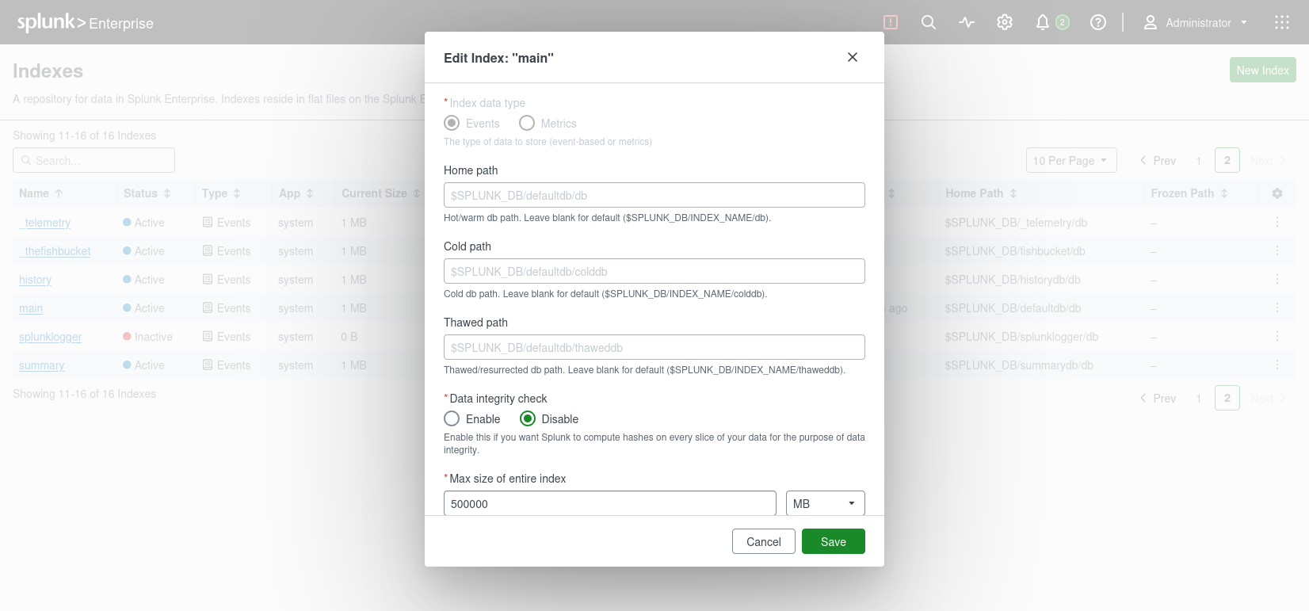
Figure 4 – Edit Index “main” – data type, paths and data-integrity settings
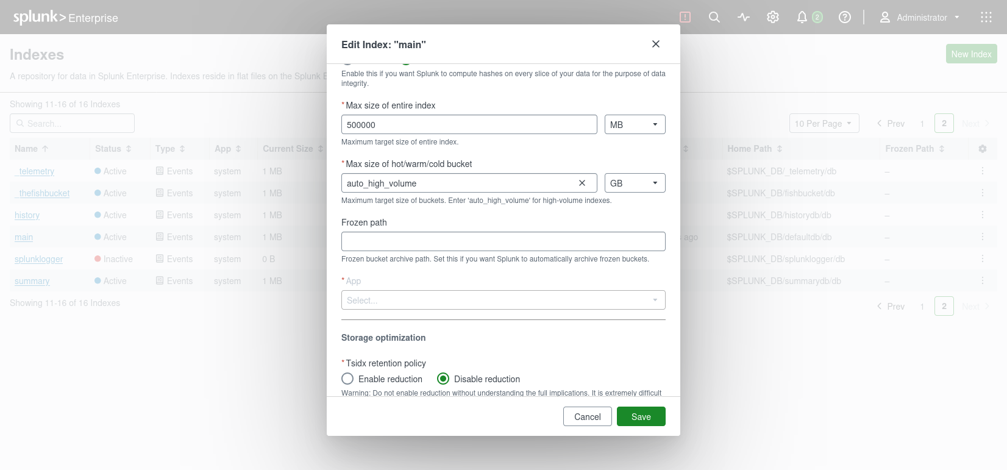
Figure 5 – Edit Index “main” – size limits, frozen path and storage optimization

5. Search and Event Analysis
The search work included counting events by source and source type and sorting the results by source (Figure 6), using the query index=main | stats count by source sourcetype | sort source. A second search against the main index, limited to the CSV source and the first three events, displayed selected fields in a table: time, host, event type, user, action, result, bytes sent and duration in seconds (Figure 7).
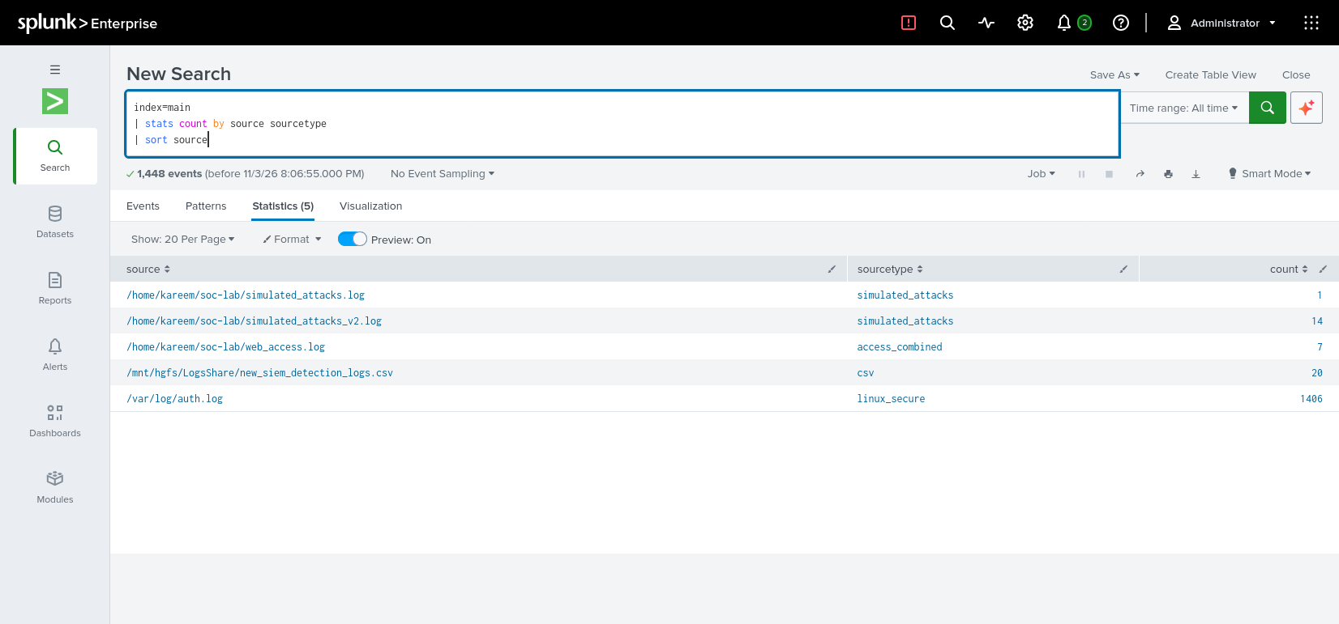
Figure 6 – Event count by source and source type (1,448 events, all time)
The search returned 1,448 events in total (capture time: 3 November 2026), distributed across the five indexed sources as follows:
Source | Source type | Event count
simulated_attacks.log | simulated_attacks | 1
simulated_attacks_v2.log | simulated_attacks | 14
web_access.log | access_combined | 7
new_siem_detection_logs.csv | csv | 20
auth.log | linux_secure | 1,406
Total |  | 1,448
Note: the counts are taken from the Statistics view in Figure 6 and sum to 1,448. Event counts grow over time because auth.log is continuously updated, so the figures are valid for the capture time of the screenshots. The linux_secure source type is Splunk’s built-in type for the Linux authentication log (/var/log/auth.log), which is also referred to as the OS log.

6. Observed Event Details
A set of three data-transfer events (event_type = data_transfer) was reviewed in Figure 7. All three were reported with a successful result and the same action, outbound_transfer. The users were student, analyst, and student, respectively. The events share the date 22 October 2026, with times 10:34:00, 10:33:00, and 10:32:00.
The host shown for these events was kareem-VMware-Virtual-Platform. The recorded bytes_sent values were 580,000,000; 1,200,000; and 720,000,000, with corresponding durations of 65, 30, and 90 seconds. Process name, command line, destination IP, and destination port were blank in the displayed results.
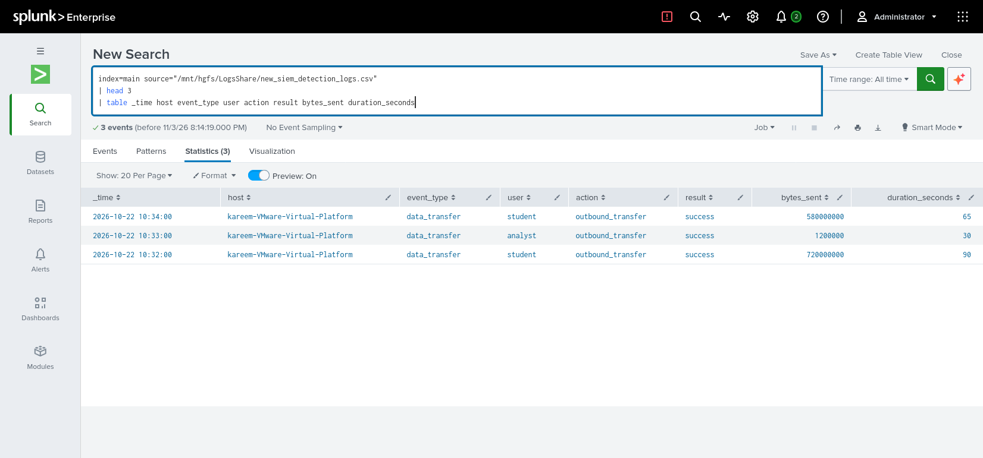
Figure 7 – Selected fields of three events from new_siem_detection_logs.csv

7. Field Availability and Data Quality
The field review showed that several fields were populated while others were empty or had zero values. Fields observed as available included action, bytes sent, event type, extracted host, extracted source type, index, line count, source, source type, Splunk server, timestamp, and user. Fields such as command line, connection count, destination IP, destination port, process name, interval, and several time-partition fields were reported as empty or zero in the reviewed event.
This is documented as an observation about the available dataset and field extraction, not necessarily as a Splunk platform fault. Some fields may not exist in the source events or may require additional extraction.

8. Screenshots and Evidence
The project evidence set includes eight figures in this document: (1) the lab SIEM architecture diagram; (2–3) terminal output of the Splunk list-monitor command; (4–5) the upper and lower sections of the main-index configuration; (6) event counts grouped by source and source type; (7) a table of selected event fields; and (8) the proposed medium-organization architecture.
Recommended evidence filenames, following the figure order:
- 01 - SIEM Architecture.png
- 02 - Splunk Monitored Files - Terminal Part 1.png
- 03 - Splunk Monitored Files - Terminal Part 2.png
- 04 - Main Index Settings - Part 1.png
- 05 - Main Index Settings - Part 2.png
- 06 - Event Count by Source and Source Type.png
- 07 - Main Index Search Results.png
- 08 - Medium Organization SIEM Architecture.png

9. Data Source Inventory by Organization Domain
The inventory below classifies the data sources currently onboarded in this lab. This is a lab inventory, not a claim that every enterprise domain is connected. Network and cloud telemetry are not currently represented by a dedicated onboarded source in the evidence. Figure 8 shows how these domains would feed a Splunk-based SIEM in a medium organization.
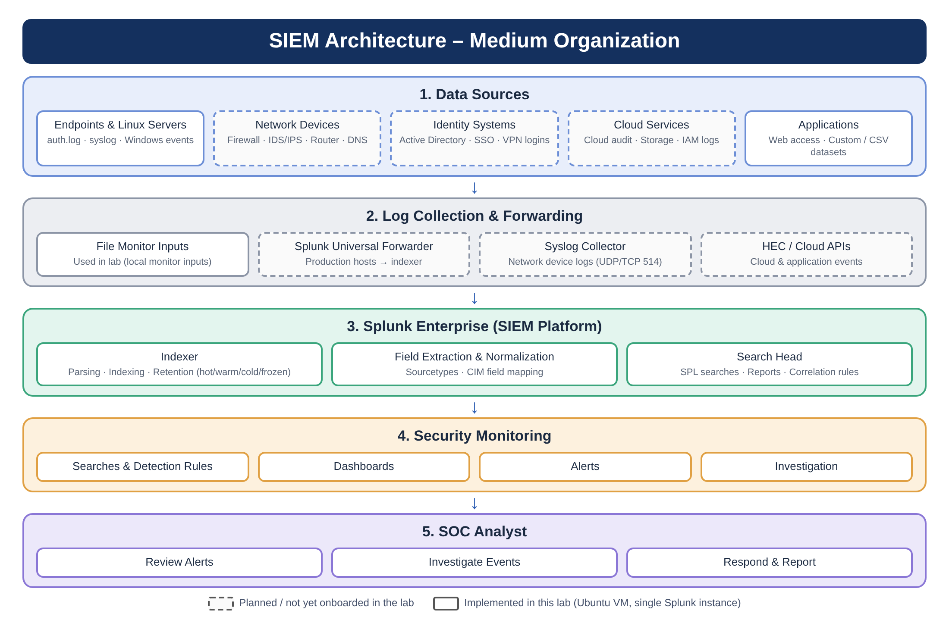
Figure 8 – Proposed SIEM architecture for a medium organization (dashed boxes are planned sources, not onboarded in the lab)
Domain / category | Onboarded source | Purpose / notes | Status
Endpoint / OS | Linux authentication log: /var/log/auth.log (sourcetype linux_secure) | Authentication and system access activity from the Ubuntu lab VM. | Onboarded
Identity | auth.log (linux_secure) | Provides OS-level authentication events; no separate identity-provider feed is shown. | Partially represented
Network / web | web_access.log (sourcetype access_combined) | Web access records for request activity; does not represent full network telemetry such as firewall or IDS logs. | Onboarded (web access only)
Applications / security dataset | new_siem_detection_logs.csv (sourcetype csv) | Custom SIEM detection dataset with event fields such as user, action, result, bytes_sent and duration_seconds. | Onboarded
Security testing / simulated activity | simulated_attacks.log and simulated_attacks_v2.log (sourcetype simulated_attacks) | Simulated attack records used for lab monitoring and analysis; synthetic rather than production endpoint telemetry. | Onboarded
Cloud | No cloud source configured in the provided evidence. | Cloud audit logs are a potential future onboarding source. | Not onboarded
Network infrastructure | No dedicated firewall, IDS/IPS, or router log source configured in the provided evidence. | A future source could expand network visibility. | Not onboarded

10. Normalized Field Mapping
The table maps the raw Splunk fields of each onboarded source to Splunk Common Information Model (CIM) field names, with the suggested CIM data model. Rows marked “Verified” use fields seen in the Splunk search results (Figures 6 and 7). Rows marked “To confirm” use standard field names for the sourcetype and should be validated in the data with | fieldsummary. The current evidence does not show a configured CIM data model, Field Aliases or custom extractions, so this is a documentation-level mapping.
Source | Sourcetype | Raw field | CIM field | CIM data model (suggested) | Status
new_siem_detection_logs.csv | csv | _time | _time | All | Verified
new_siem_detection_logs.csv | csv | user | user | Authentication / Change | Verified
new_siem_detection_logs.csv | csv | action | action | Authentication / Change | Verified
new_siem_detection_logs.csv | csv | result | result | Alerts / Change | Verified
new_siem_detection_logs.csv | csv | event_type | category | Alerts | Verified
new_siem_detection_logs.csv | csv | bytes_sent | bytes_out | Network Traffic | Verified
new_siem_detection_logs.csv | csv | duration_seconds | duration | Network Traffic | Verified
new_siem_detection_logs.csv | csv | host | dest | Network Traffic / Endpoint | Verified
web_access.log | access_combined | clientip | src | Web | To confirm
web_access.log | access_combined | method | http_method | Web | To confirm
web_access.log | access_combined | uri_path | uri_path | Web | To confirm
web_access.log | access_combined | status | status | Web | To confirm
auth.log | linux_secure | user | user | Authentication | To confirm
auth.log | linux_secure | src | src | Authentication | To confirm
Note: bytes_sent, duration_seconds and host require Field Aliases (or calculated fields) to appear under their CIM names (bytes_out, duration, dest). Fields such as process_name, command_line, destination_ip and destination_port were blank in the reviewed events and are therefore not mapped.

11. Log Retention Plan
Retention requirements are documented separately from the observed index configuration. The screenshots show that the main index has a maximum size of 500,000 MB, the hot/warm/cold bucket size is set to auto_high_volume, and the frozen path is not set. The exact configured retention duration is not established by the current evidence.
Retention stage | Project plan | Current configuration / limitation
Searchable retention | Proposed target: retain logs searchable for 30 days, subject to project/organization requirements and available storage. | Duration needs to be confirmed/configured in Splunk; current evidence does not show a numeric retention period.
Archive | Proposed additional archive period: up to 60 days (90 days total) if an approved archive location is available. | Frozen path is currently not set, so archive workflow is not configured in the documented index.
Expiration / disposal | After the approved retention period, remove expired data according to the project policy. | The documented current behavior is deletion at expiration rather than archiving because no frozen path is configured.
Capacity guardrail | Monitor index size and storage use; index maximum is 500,000 MB. | This is a size limit, not by itself a retention-duration guarantee.

Note: The 30-day searchable and 60-day archive targets are proposed documentation values, not verified live Splunk settings. They should be confirmed with the project supervisor or brief before being treated as an implemented policy.

12. Conclusion
The project demonstrates a working Splunk-based log-monitoring workflow in an Ubuntu virtual environment. Multiple log sources were configured for monitoring, the main index was reviewed, and searches were used to inspect event volumes and selected event fields. The collected evidence documents the monitored inputs, index configuration, and example event records. Further refinement could include improving field extraction for currently empty fields and creating visual dashboards or alerts if required by the project brief. The Week 1 inventory also identifies domains not yet onboarded (cloud and dedicated network infrastructure), while the CIM-based field mapping (verified for the CSV source, to be confirmed for web and authentication logs) and the retention targets are documented as proposed items where live configuration evidence is not available.

Appendix: Search Examples
Event counts by source and source type:
index=main | stats count by source sourcetype | sort source
Selected event fields from the CSV source:
index=main source="/mnt/hgfs/LogsShare/new_siem_detection_logs.csv" | head 3 | table _time host event_type user action result bytes_sent duration_seconds

